|  |
| --- |
|  |
| Bunty |
|  |
| Version #1.6.0  All work Copyright © 2012 by G Studio.  All rights reserved. |
| **Vishal Guleria 300813391** |
|  |



|  |
| --- |
| February 29, 2016 |

**Table of Contents**

Table of Contents

Game Overview 4

Camera 4

Controls 4

Interface Sketch 5

Menu and Screen Descriptions 6

Game World 8

Levels 8

Level 1 8

Level 2 8

Level 3 8

Characters/Objects 8

Saviour Ship 8

Non-player Characters 8

Enemy Ship 8

Planet 8

Enemies 9

Enemy Ship 9

Vehicles 9

Saviour Spaceship 9

Enemy Ship 9

Scoring 9

Lives 9

Scores 9

Sound Index 9

Background Music 9

Collide sound clip 9

Score sound clip 9

Finish music 9

**Version History**

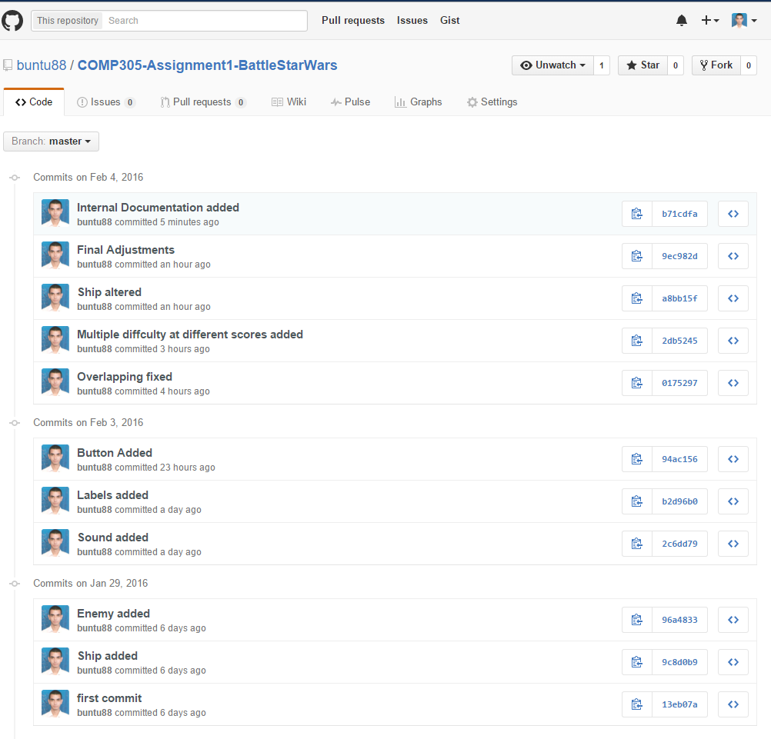

# Game Overview

In the 2D platform game, Bunty, the main avatar is a prince who want to go to his castle. But to do that he has to go through a fearful creature “Dragon”. He can also collect life potion in order to gain points. During the mission, if prince hits Dragon, he will die. Also if he falls form the platform then also he loses its one life and has to start over again. The prince has to jump above the benches and also need to avoid obstacles to move forward.

# Camera

This is 2D game, so orthographic side view is used for the camera.

# Controls

The controller for this game would be keyboard keys. The gamer can use the arrow keys i.e. “Right” and “Left” to move the prince in horizontal direction whereas the “Up” arrow keys is used to jump the prince in the vertical direction. But prince will only jump while he moves. Also the user can use the key “A” and “D” to move the prince and “W” to it jump. The game does not use a mouse control.

# Interface Sketch

Main Screen

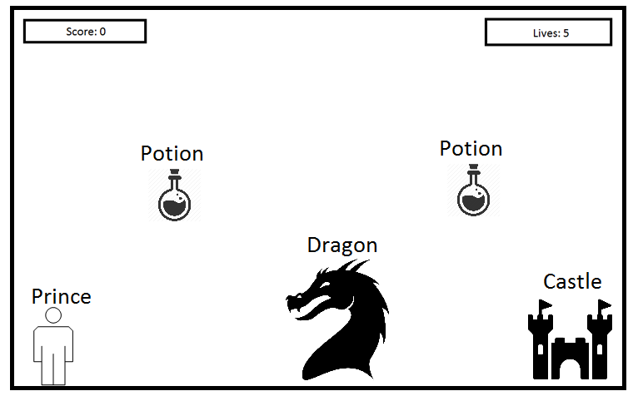

Finish Screen

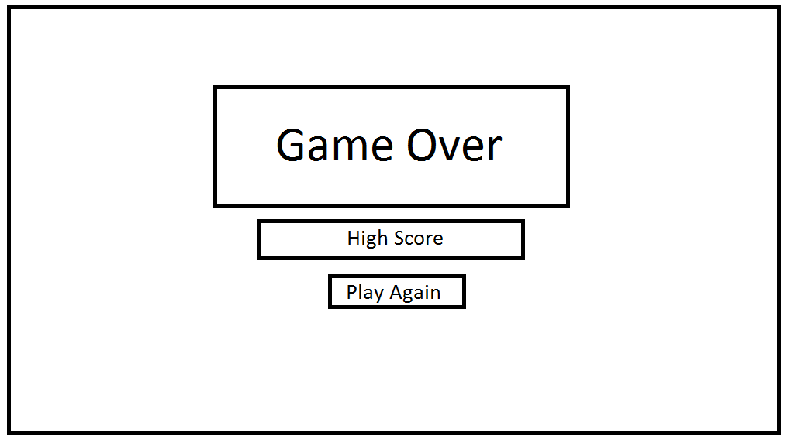

# Menu and Screen Descriptions

**Game Screen**

Below is the playing screen of the game. Player can go on top of the planets to collect point, but at the same time player has to save ship from enemy ships in the game.

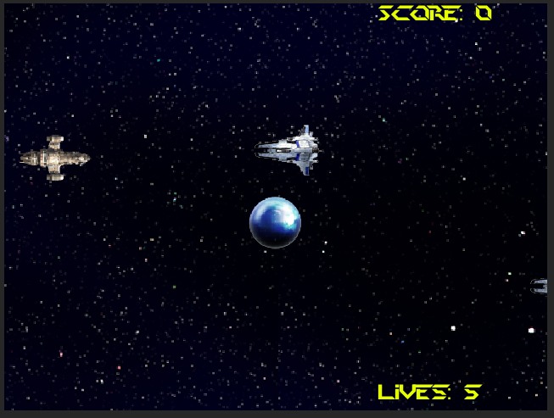

**Finish Screen**

If the player loses all his 5 lives, game gets over. Player can play again by pressing try again button.

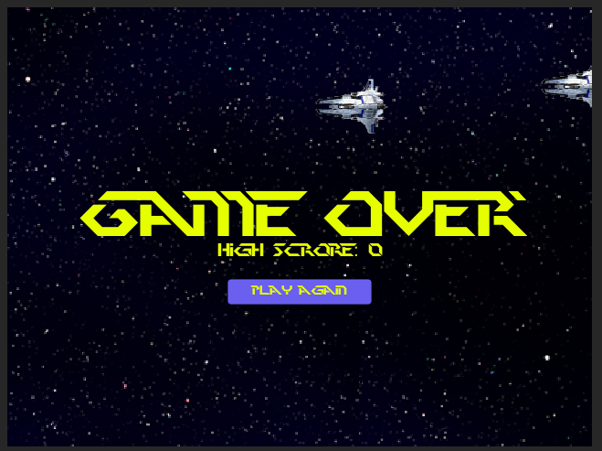

# Game World

In this diversion, principle foundation is the space. The whole amusement has top perspective of the space with various ships and planets in it. Primary symbol is a boat. Player sees everything from the top. As the boat goes ahead, it confronts numerous boats as impediments particular to every level. Player needs to keep away from all these with a specific end goal to survive and gather the focuses by means of proceeding onward top of the planet and push ahead.

# Levels

### Level 1

Level 1 will have 2 enemies space ships for the player to challenge.

### Level 2

Level 2 will come after user scores 1500 points and will have 3 enemies space ships for the player to challenge.

### Level 3

Level 2 will come after user scores 3000 points and will have 4 enemies space ships for the player to challenge.

# Characters/Objects

### Saviour Ship

The main character or AVATAR in this game is a Saviour Ship. Player’s main goal is to control the up and down movement of ship with the Up and Down key on the keyboard to get points by moving ship over to the planet and avoid collisions with enemy ships.

# Non-player Characters

### Enemy Ship

Enemy ships will be controlled by Game Controller script which will try to destroy the Savour spaceship.

### Planet

Savour space ship can move on top of the planet to gain points and increase score.

# Enemies

### Enemy Ship

Enemy ships will be controlled by Game Controller script which will try to destroy the Savour spaceship.

# Vehicles

### Saviour Spaceship

The main character or AVATAR in this game is a Saviour Ship.

### Enemy Ship

Enemy ships will be controlled by Game Controller script which will try to destroy the Savour spaceship.

# Scoring

### Lives

One life gets reduced each time saviour space ship is colliding with enemy space ship. Player has 5 lives in starting.

### Scores

100 scores are awarded for each shell

# Sound Index

### Background Music

SpaceMusic.mp3

### Collide sound clip

Blast.mp3

### Score sound clip

Achive.mp3

### Finish music

GameOver.mp3